Hands-on: Orange3 in Text Analysis

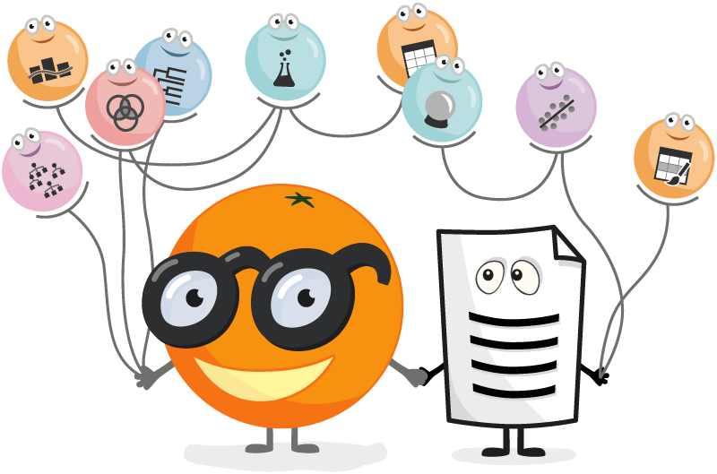

The goal of this hands-on activity is to be familiar with Orange3 and Text Analysis addon. Specifically the tutorials will cover: Intro to Orange3, Groupings of similar texts, Text mining to extract meaningful relations, and Predicting sentiments from various texts found in social media.

**What is Orange3?**

* <https://orangedatamining.com/>
* An open source machine learning and data visualization.
* It can build data analysis workflows visually, with a large, diverse toolbox (widgets).
* Used at schools, universities and in professional training courses across the world, Orange supports hands-on training and visual illustrations of concepts from data science.
* There are even widgets that were especially designed for teaching, professional work, research etc.

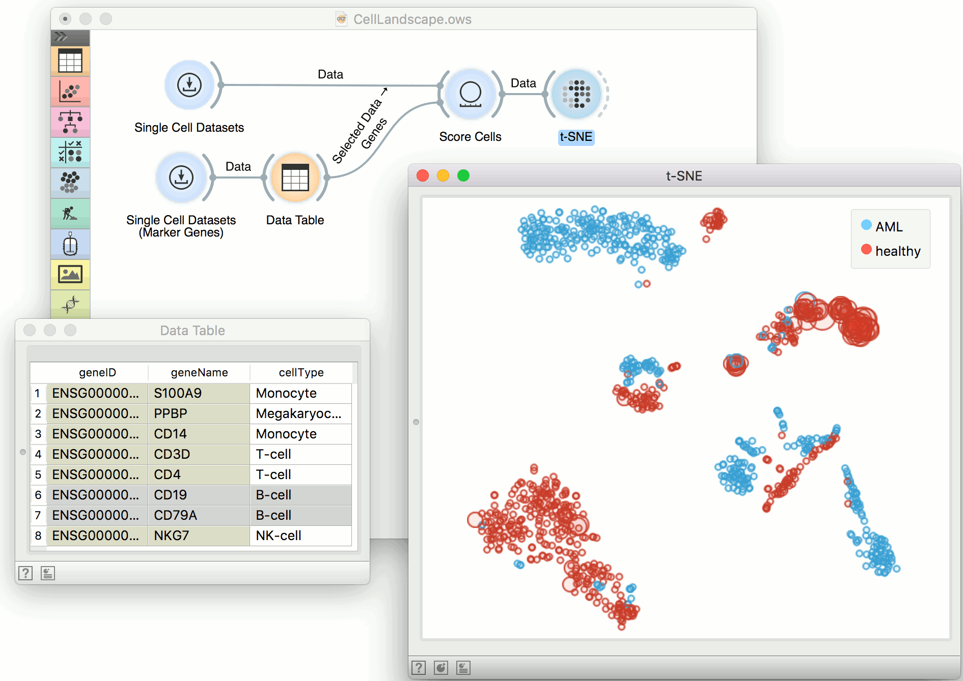

**Now:**

* Download and install the latest version <https://orangedatamining.com/download>
* Take a look at the documentations at <https://orangedatamining.com/widget-catalog/>, widgets and visit some of them to read:

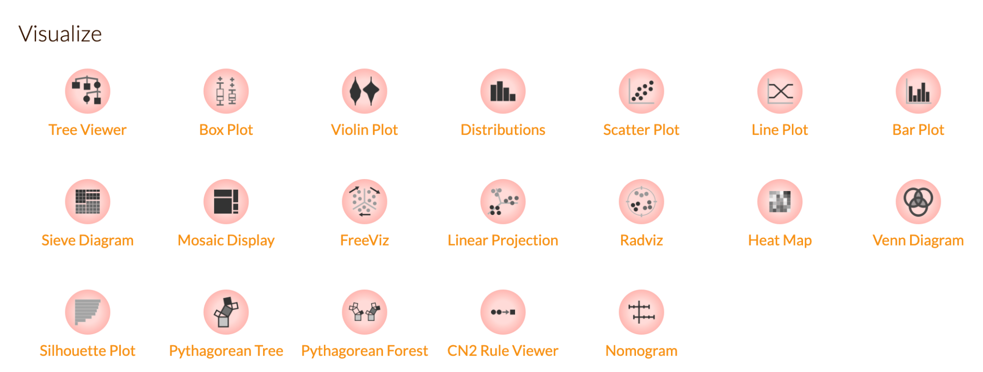

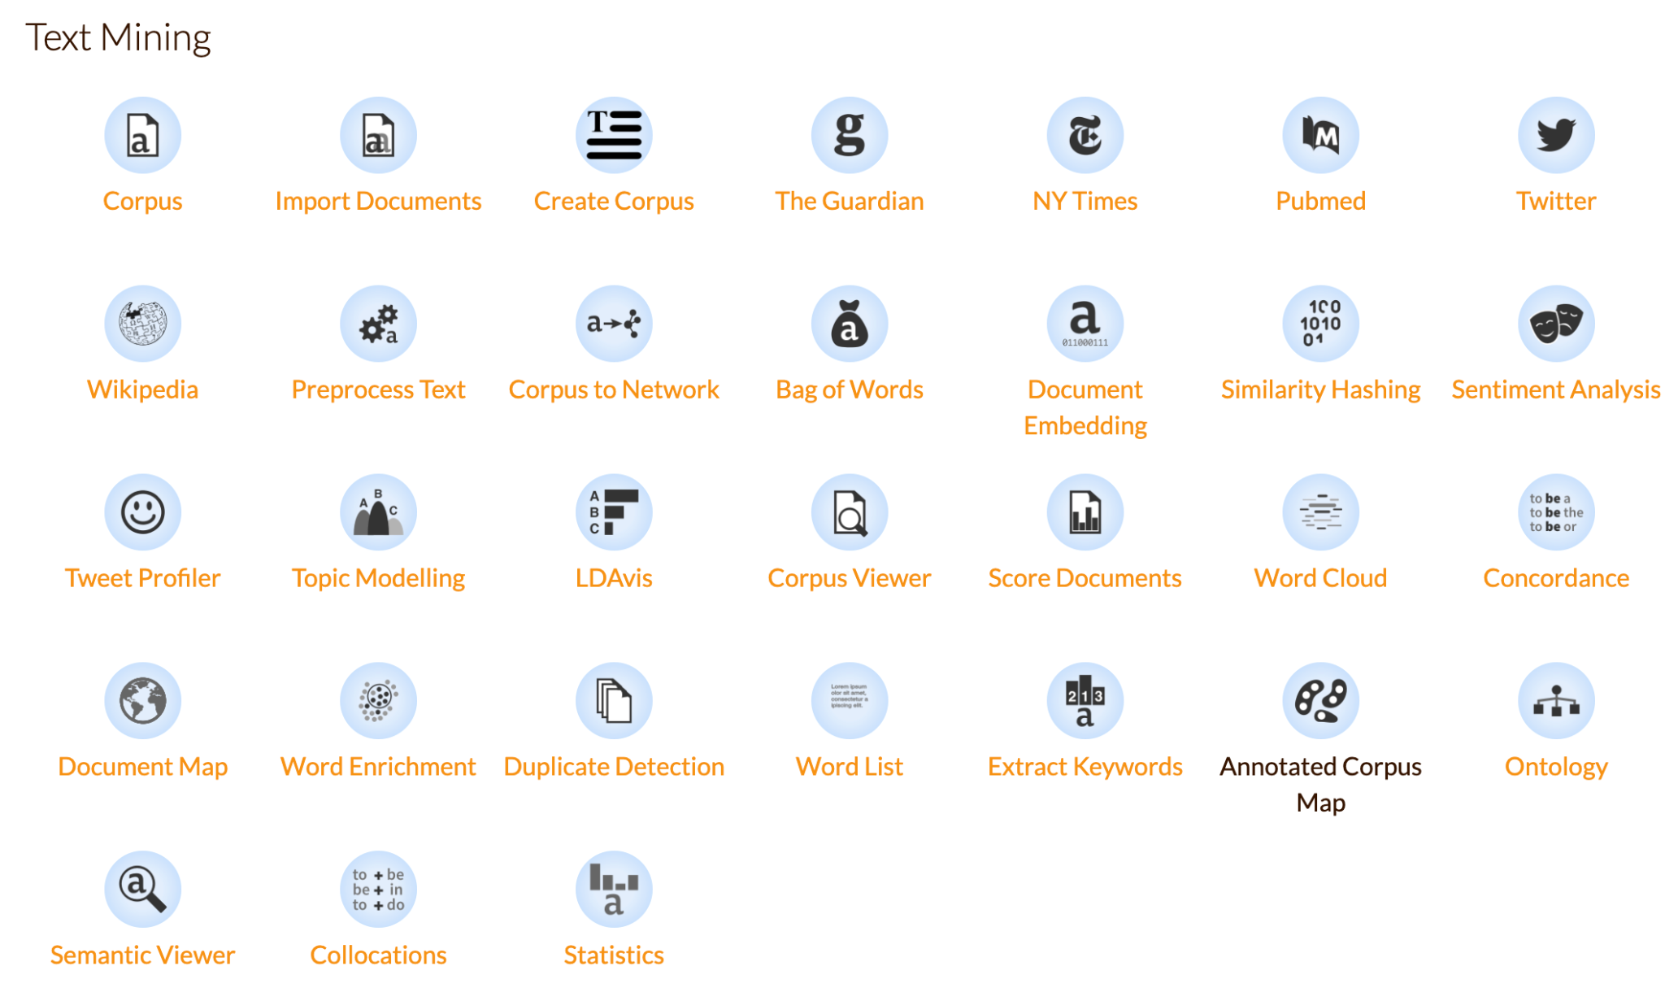

* Browse <https://orange3-text.readthedocs.io/en/latest/index.html> to check for the capacity of the software.
* Check for examples when opening the software:

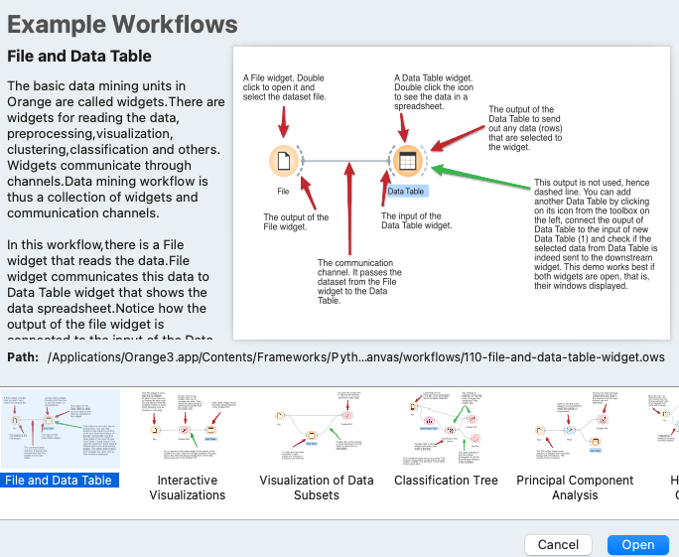

See example workflows: just try and observe 2-3 of them

* Visit <https://www.youtube.com/c/OrangeDataMining/playlists> and see the **Text Mining** playlist. Just take a look briefly.

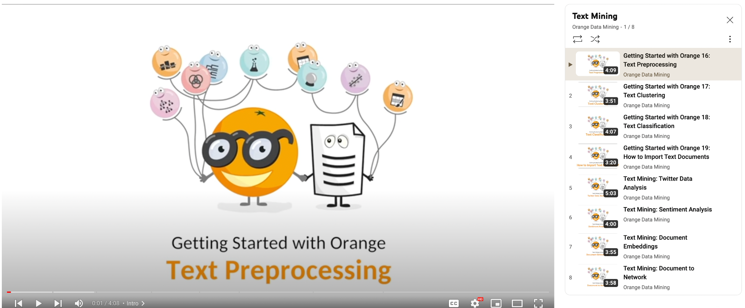

* Before practicing the playlist, make sure to install `Text` Add-on under Options. Close and reopen Orange3.

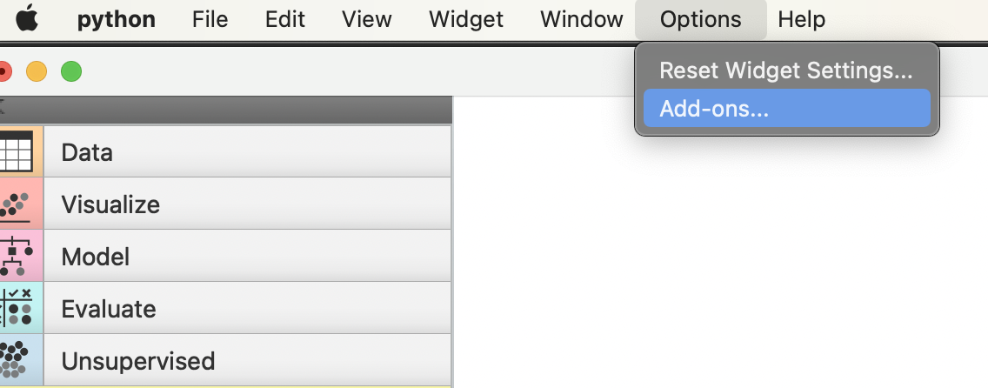

* I prepared a [short video](https://rit.zoom.us/rec/share/lFcPAAvIIdoh7-7VhAk5ug-qLq5XEiW-2i1cekJLmGx3Jkrhx-Io2eYd71FEdXSG.wBwaefiWkTmsPKW0?startTime=1667151301000) for the first session with Orange3. It is also under Week 10. First watch it.
* Then complete all the eight short tutorials under the **Text Mining** playlist, <https://youtu.be/V70UwJZWkZ8>.

This is the end of the tutorials **after you submit two screenshots on Discussions** under Week-10’s hands-on topic.